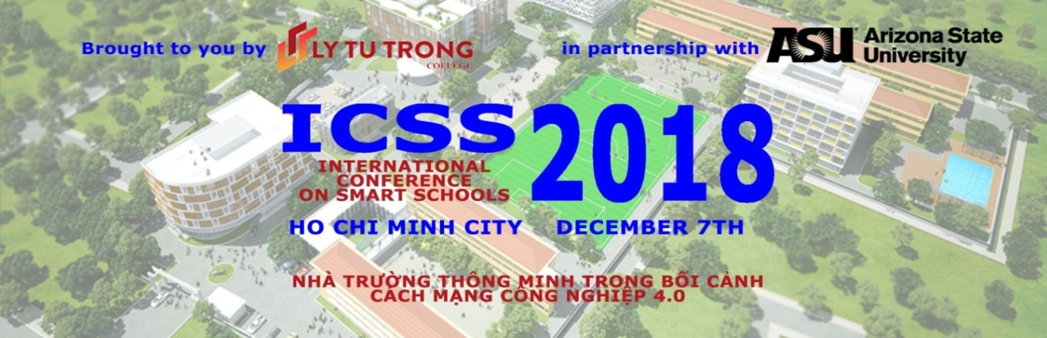
December 7th, 2018
Dear Conference participants,

On behalf of Ly Tu Trong College of Ho Chi Minh City, we would like to sincerrely thank you for your important participation in, and contribution of ideas and experiences to the International Conference on Smart Schools 2018 in the Context of the 4th Industrial Revolution (ICSS), held on December 7, 2018, in Ho Chi Minh City.
We hope that you have found the conference informative and useful. The lessons learned from of other countries pioneering in IT and education have helped us recognize challenges and opportunities brought by revolution industry 4.0 an d, impacts of on vocational education and to build up smart schools suitable to Vietnam with the presence of international and local expertises, professors and lectures from around the world in open discussions. We believe that our diverse and dynamic group of presenters and panelists provided in-depth insights as well as actionable and practical tools of engagement models and methods.
In order to make next year’s conference even more successful, we would love to continue receive your support, sponsors and feedbacks smart schools to make great contribution to the development of vocational education as well as our nation in the era of industrial revolution 4.0.
We wish you excellent health, happiness and prosperity.

Conference Chairmain
Meritorious Teacher PHAM HUU LOC

